**CIS 452 02 – Assignment 4 – Gabe Baksa**

1. **Implement the thread code to the left**

**#include <pthread.h>**

**#include <stdio.h>**

**void* happy (void* arg) {**

**int* N = (int *)arg;**

**for (int k = 0; k < *N; k++) {**

**printf("Happy %d\n", k);**

**}**

**return (void*) 0xF00D;**

**}**

**int main () {**

**pthread_t happy_id;**

**pthread_attr_t happy_attr;**

**pthread_attr_init (&happy_attr);**

**int threadArgument;**

**threadArgument = 6;**

**pthread_create (&happy_id, &happy_attr, happy, &threadArgument);**

**for (int k = 0; k < 20; k++) {**

**printf("Before %d\n", k);**

**}**

**int joinReturnValue;**

**pthread_join (happy_id, (void**) &joinReturnValue);**

**printf("Thread status is %x\n", joinReturnValue);**

**printf("End of program\n");**

**return 0;**

**}**

1. **When you run the code, what output do you get? Does the output change over different iterations?**

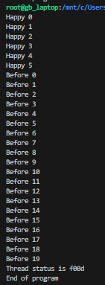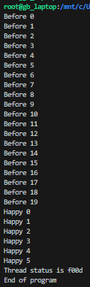

Outputs may be different each time the program is run.

1. **Change the number of times the happy worker method prints its message to 10. Make this change without modifying the happy method itself.**

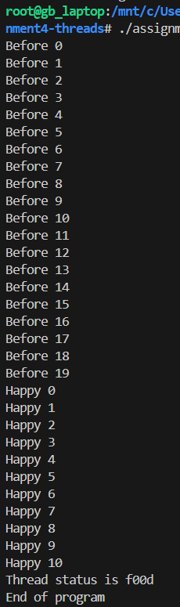

Changed the threadArgument to 11 so the the loop inside happy runs while k < 11 so Happy prints 10 times.

1. **Change the return value for the ‘happy’ worker thread. Are there any limitations for what you can return?**

Yes, the return value must be an address, and it cannot be of a local variable.

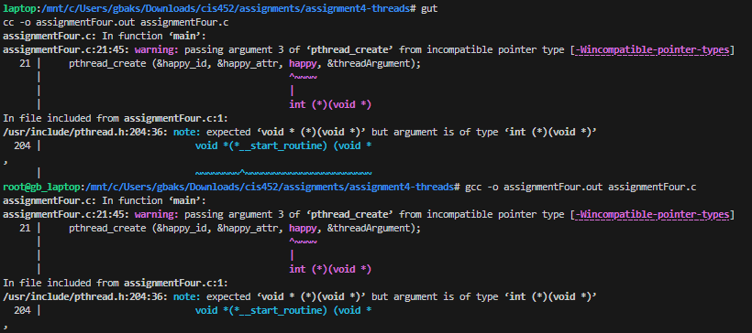

1. **Submit your modified code along with a word document under the in-Class Assignment**